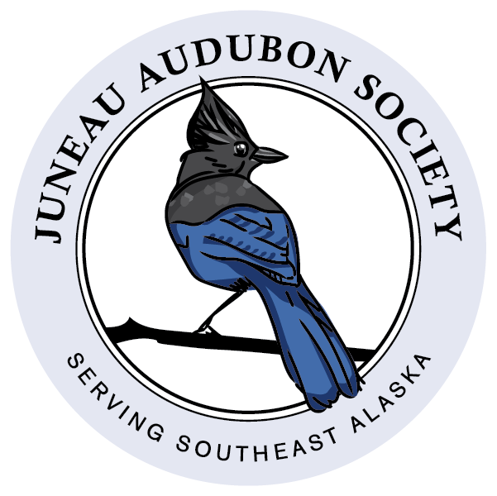

2024 Juneau Audubon Society Membership Form

- New or renewing JAS Chapter Member $10
- Additional support for JAS programs $_______

Total Enclosed: ________________

Note that we are phasing out paper copies of the
JAS Raven. Please be sure to provide your email
so we can send it to you electronically!
*Note that JAS DOES NOT send members any offers
or share our membership addresses with anyone.

- I don’t have an email and need to receive a paper
copy of the JAS Raven
Please consider an extra donation to cover
the costs of printing and postage, thanks!

Name: ______________________________________

Address: ____________________________________

___________________________________________

City: _______________________________________

State: _____________ Zip: __________________

Phone: _____________________________________

Email: ______________________________________

- I would like to hear about JAS field trips, bird walks, and other educational activities.

- I would be interested in volunteering with JAS for projects, bird walks, and/or educational activities.

Please make your tax-exempt check payable to:
Juneau Audubon Society
PO Box 21725
Juneau, AK 99802-1725

Membership renewals are due in January each year. JAS memberships run through the calendar year from January to December (Memberships made after Sept 1st will carry forward through the next year).
You can use this form or join/renew through our website: www.juneauaudubon.org. Please contact Membership@juneau-audubon-society.org for questions about membership.

If you prefer, you can join the National Audubon Society online at https://www.audubon.org/membership which includes automatic membership in the local chapter, which is JAS if your zip code is anywhere in Southeast Alaska.
******************************

The mission of the Juneau Audubon Society:
"To conserve the natural ecosystems of Southeast Alaska, focusing on birds, other wildlife and their habitats for the benefit and enjoyment of current and future generations.”
Thanks for joining us or renewing your membership!

